**ECON 136: Week 7, Monday**

**Thinking About Non-Market Activities and**

**Modeling Externalities**

A) Examples of Non-Market Activities

1) Taxation, by leading to a deviation from the market outcome, bears the cost of imposing an efficiency loss (DWL) on society.

2) Friday at Bryn Mawr: Explain how property taxes to fund nearby environmental amenities could be economically efficient.

3) Friday at Camden: Education is an example of a service that is accomplished largely as a non-market activity. Even in the absence of financial aid, tuition at Bryn Mawr and Haverford covers less than half the average cost of academic work. K-12 public and charter schools are free. Fees at parochial schools, such as Sacred Heart, are a fraction of the actual cost. What resources did you observe having to be brought to bear to educate the fifth graders at Sacred Heart that, in other settings (or even to some extent in this setting) would have been allocated based on market exchange? That is, to what extent did Sacred Heart look like a seller of educational services?

B) Two Cheers for Markets

1) Cheer 1: The model works when markets are reasonably competitive

We can predict how markets respond to external changes

Attempts to deviate from market outcomes tend to fail

2) Cheer 2: Economic efficiency and welfare

The greatest good for the greatest number

Pareto efficiency

The invisible hand – no need for politics

We reap what we sow

C) If Markets Are So Great, Why Do We Weep?

Bad outcomes arguably are the result of:

An (inappropriate, immoral, unjust) initial allocation of resources

Non-Pareto improving growth where harm to losers violates cultural norms

One or more market failures

Externality market failure is the most relevant to environmental problems

Inappropriate government intervention

D) Externalities

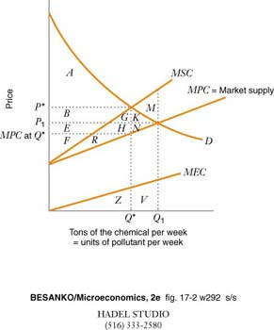The effect that an action of any decision maker has on the well-being of other consumers or producers, beyond the effects transmitted by changes in prices. An externality arises when buyer and seller fail to consider benefits or costs to third parties.

A **negative externality** imposes costs on third parties not borne by the buyer or seller.

MPC = marginal private cost

MEC = marginal external cost

MSC = marginal social cost = MPC + MEC

Market outcome: where S = MPC = MPB = D

Efficient, social optimal outcome:

where MSC = MSB

The deadweight loss of any deviation from the socially optimal outcome is the area between

Market output (Q1) and socially desired output (Q*); and

Marginal social cost and marginal social benefit (D)

Here, since MSB = MPB = D, DWL = M

Example: Suppose the demand for oil is given by PD = 90 – 0.5Q in millions of barrels and that the marginal private cost of producing oil is PS = 10 + 0.3Q. A toxic byproduct of oil drilling causes a marginal external cost of 0.2Q. Draw an appropriate diagram to illustrate and use algebra to confirm that

a) the market equilibrium will yield 100 million barrels of oil at a price of $40/barrel;

b) the socially efficient (MSC = MSB) output is 80 million barrels

c) the deadweight loss associated with the market equilibrium is $200 million.